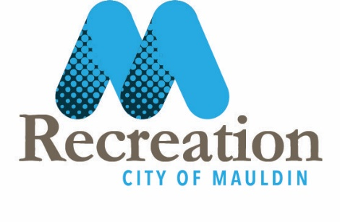
Summer Day Camp Counselor
City of Mauldin- Mauldin Recreation
Starting Pay Rate: $10.00 per hour
Seeking energetic, responsible, playful individuals to join Mauldin Recreation as summer day camp counselors! Assists the Camp Director, Assistant Camp Director, and additional Mauldin Recreation Staff in organizing and presenting a diversified day camp program and supervises program participants to maintain order and safety.
Additional duties and responsibilities include, but are not limited to: assisting with preparation of camp calendars, assisting with camp/field trip registration procedures, assisting with planning and presenting daily programs (games, arts and crafts, sports activities, nature activities, field trips, etc.), setting up for & cleaning up after programs and activities, assisting with maintaining activity supplies and materials, and communicating effectively with parents, etc.
Qualifications: Requires HS diploma (or equivalent), a minimum of three months relevant experience, & valid state driver’s license. Must possess or obtain current CPR/First Aid/AED certification. Mauldin Recreation will provide this training to staff.
***THIS POSITION IS CONSIDERED TO BE SAFETY SENSITIVE AND IS THEREFORE SUBJECT TO PRE-EMPLOYMENT DRUG TESTING & RANDOM DRUG TESTING***
Summer Camp dates are June 17th thru August 9th.
There will 3-4 Sessions of Staff training prior to camp beginning.

