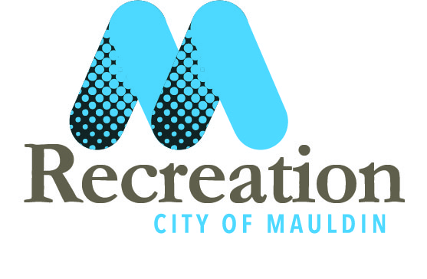

- Registration Fee:
  - Includes the rental of a pair of shoulder pads and helmet. To be returned at the end of the season. Also included are game jersey and mouth piece for players to keep.
  - Not included are football pants, cleats, chin strap, and other accessories like gloves etc.

- Tryouts are: All @ Mauldin City Park (kids should wear shorts, shirt, and cleats)
  - July 22nd for 8U players (6,7,8) @ 6pm Mauldin City Park
  - July 23rd for 10U players (9,10) @ 6pm Mauldin City Park
  - July 25th for 12U players (11,12) @ 6pm Mauldin City Park

- Equipment fittings:
  - Will be at Ray Hopkins Senior Center (gym). TBA
- Practices:
  - Will begin on Monday July 29th. Practice schedule will be given to coaches and posted online www.mauldinrecreation.com at the end of the week of all tryouts. Teams will practice 3 times a week before the season starts and 2 times a week when the season begins.
- Jamboree:
  - Jamboree will be TBA @ Mauldin High School. Pictures will be taken at the same time as well.
- Season:
  - Will begin tentatively the 1st week in September
  - Games will we played against Ft. Inn, Simpsonville, and Greer
- Rec Night:
  - TBA @ High School
- Players :
  - Returning players to the same age division and team will not need to present at the tryouts
  - Players moving up to a new age division will need to be at tryouts
  - All new players to the league will need to be at tryouts.

